**Teacher of the Year Submission Instructions**

You must register an account on the Teacher of the Year website to submit your application materials.

Table of Contents

Website Instructions 1

Upload Your Files 3

Applicant Questionnaire Instructions 7

Supporting Materials Instructions including Essay Prompts 10

# Website Instructions

**Register for an Online Application Account**

1. Click on the **Register Now** link in the portal. The link takes you to the Register for an Account page.

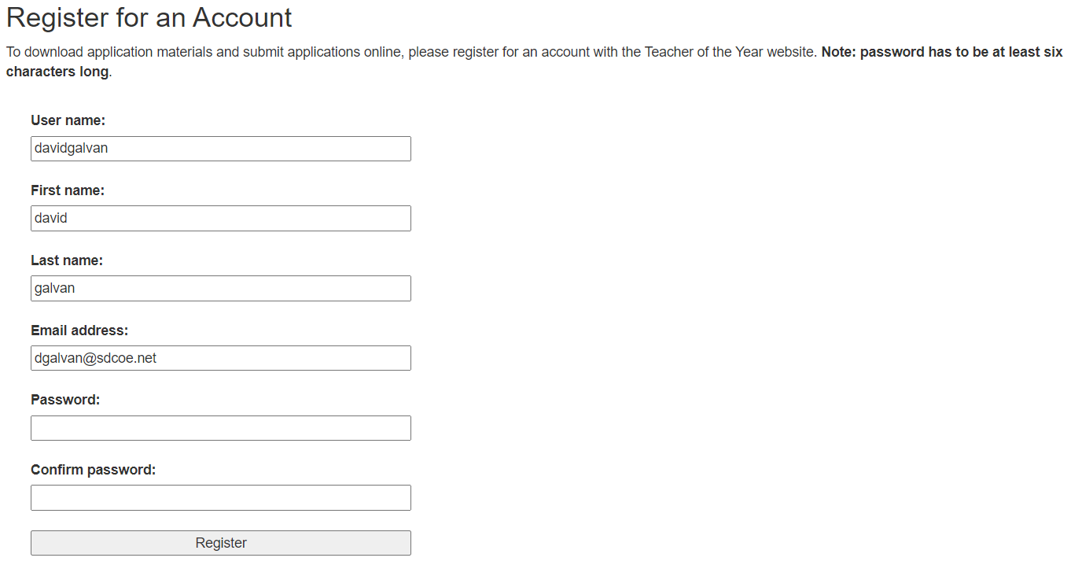

1. Complete all the form fields. Then click on the **Register** button. Once you register your account, you need to log in.

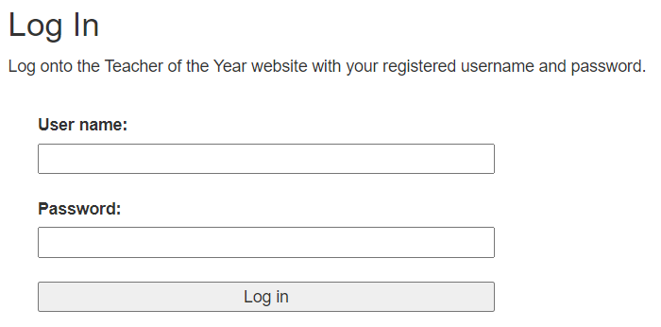

1. Enter your **username** and **password** on the log in page and click on the **Log In** button. Once you log in, you are taken to the page where you can upload your documents. This page shows you the documents that have been uploaded to the portal.   
     
   **NOTE**: You can only upload PDF and Word documents.  
     
   To upload your documents, click on the respective **Select files…** button in the panel to select your document. Click on the **SAVE APPLICATION** button to store your document in the portal.

# Upload Your Files

1. The My Application page allows you to upload the applicant questionnaire and supporting materials. Click on the corresponding **Select files…** button and select the document you wish to upload.

**NOTE:** You need to upload the Applicant Questionnaire and Supporting Materials as separate files.

1. Select the file you want to upload. Click **Open,** and the upload page will show the documents you can upload.  
     
   **NOTE**: You can only upload one file at a time  
   Graphical user interface, text, application

   Description automatically generated
2. The selected file is shown in the My Application page

1. Click the **SAVE APPLICATION** button to upload your document to the portal. Once your document is uploaded, you are taken back to the My Application page, where you can view your document(s).

1. To submit your application, you can enter a submission description (this is optional), then click on the **SUBMIT APPLICATION** button.

1. When clicking on the **SUBMIT APPLICATION** button, you are asked to confirm your application submission. Click **OK**.

1. Once you submit your application, you are taken to the My Application page, where you can review your submission status.

# Applicant Questionnaire Instructions

**Instructions to Complete and Sign your Applicant Questionnaire**

1. 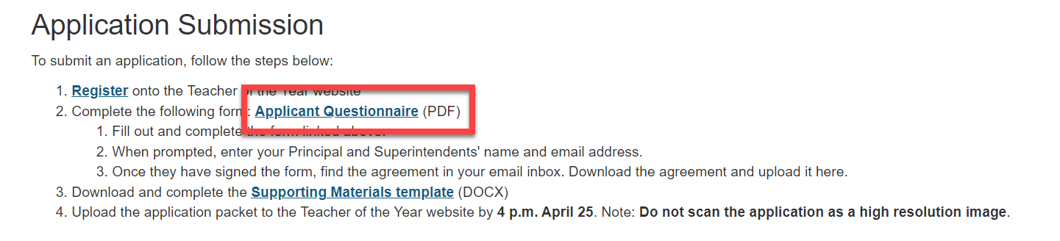  
   Click on **Application Submission** from the navigation menu, then click on **Applicant Questionnaire** on step 2.
2. Review and complete all the required fields on the form. The application can be filled out on the web browser (e.g. Google Chrome, Firefox). **There’s no need to install Adobe Acrobat Reader**. Please review the information required on this form and fill it out in one sitting. **It will not save your information.**

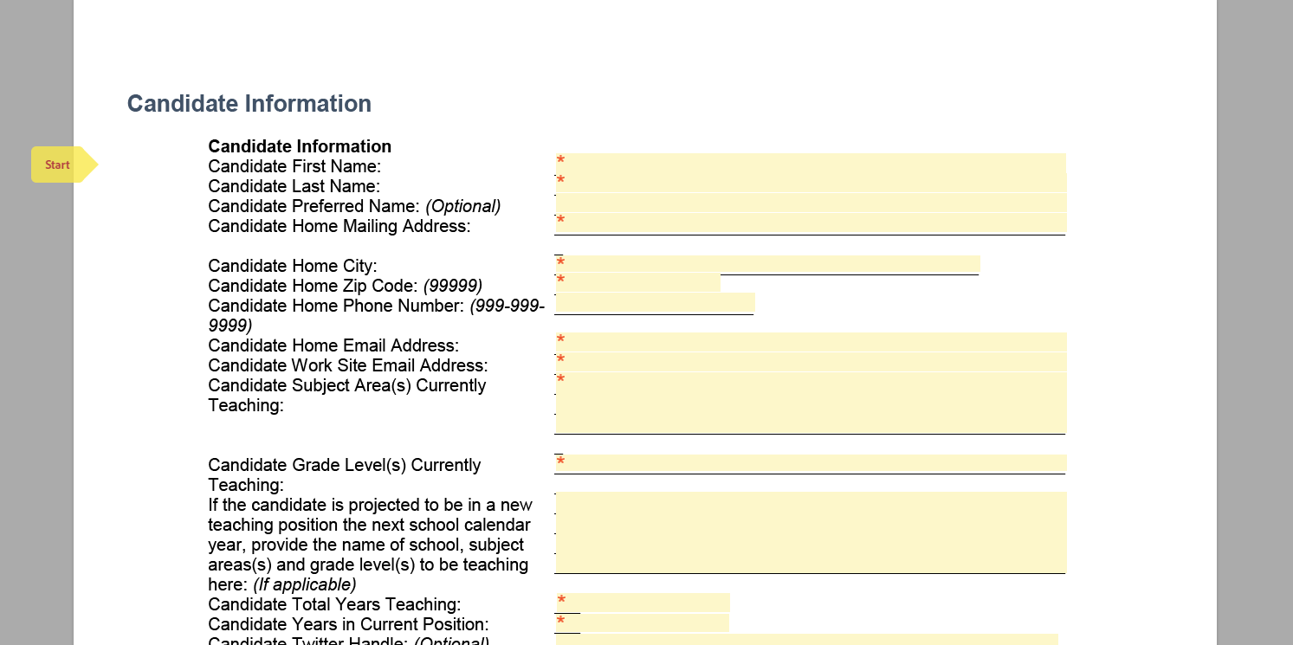

1. Click on the signature field and type out or draw your digital signature.

1. Once you have completed the form, it will prompt you to enter your principal and superintendent’s first name, last name, and email address. Optionally, you can enter your principal or superintendent’s administrative assistant. They can then **delegate** the signature to the principal or superintendent. The form will then be sent to them for signature.

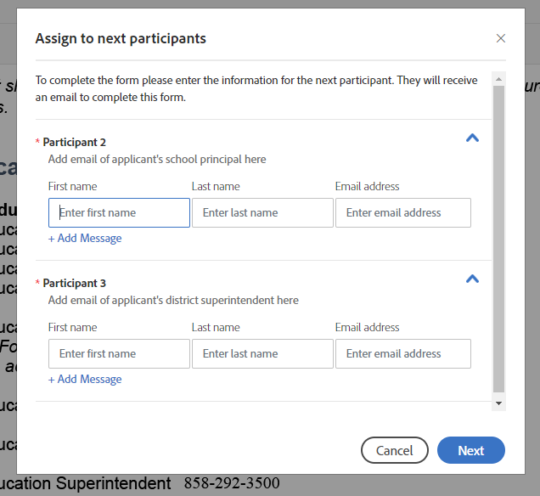

1. Upon signature completion, you will get an email with a link to download the PDF.  
   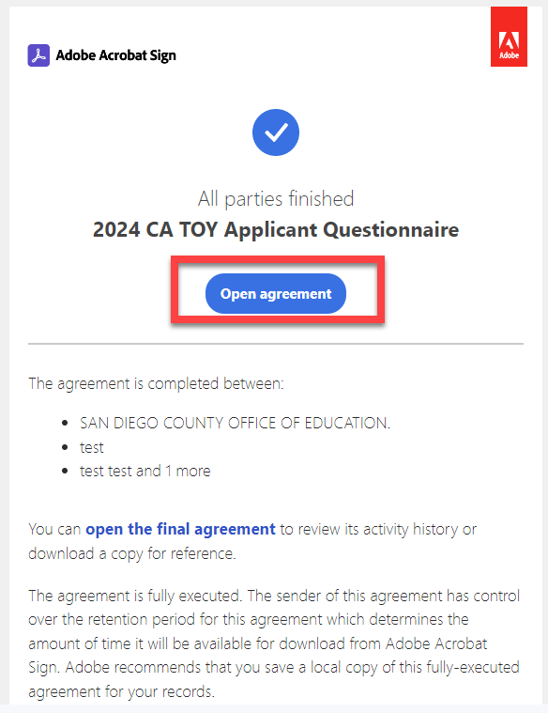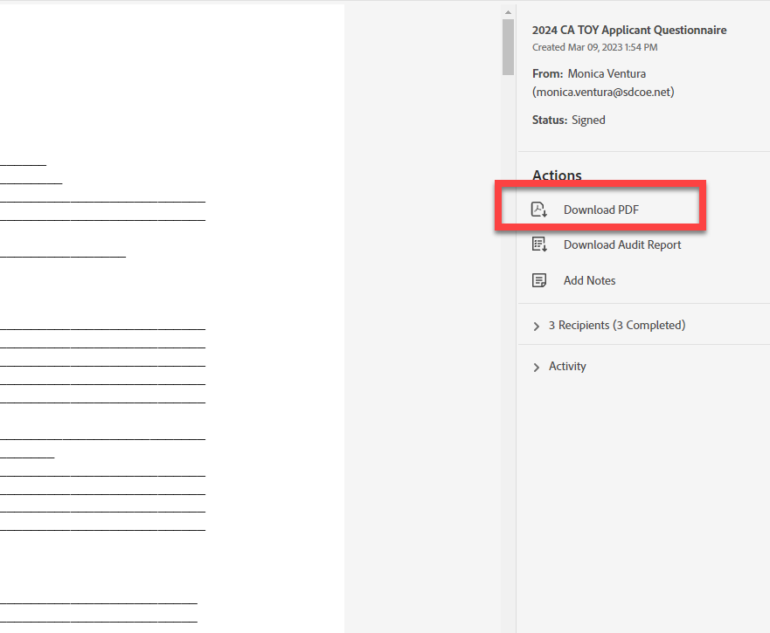

# Supporting Materials Instructions including Essay Prompts

Use the Supporting Materials template (in Word). Save it to your computer. Once you have copy and pasted your essays, letters of support, head shot, and a link to your video save it then uploaded onto the 2024 CA TOY Application website as one complete file in Microsoft Word or Adobe Acrobat.

The document is limited to 23 pages, formatted as follows:

* 1-inch margins
* Arial 12-point font
* Single-spaced

#### Documentation Components

The Documentation must include the following components:

* Cover Page
* Introductory Letter
* Professional Biography
* Professional Resume
* Essays
* Letters of Recommendation (3)
* Headshot
* Introductory Video

##### Cover Page

**Requirement Description:** Provide a cover page. **(Not to exceed one page.)**

The cover page should include the documentation name and the following information about the candidate:

* Documentation Name (County Name, District Name, followed by candidate First Name and Last Name)
* First Name and Last Name
* Grade Level(s) Teaching - Subject(s) Teaching
* School where Employed, City
* School District, County

##### Introductory Letter

**Requirement Description:** Provide an introductory letter from the candidate to the Evaluation Committee. **(Not to exceed two pages.)**

The introductory letter should present a powerful statement about your commitment to continued achievement for all students.

Include the following:

* Explain what it is like to be a student in your class.
* Relate an inspirational vignette from your own teaching experience that illustrates an important aspect of education.
* Paint a clear picture that helps the reader to envision a typical day.
* Include a brief example of an ideal real day and a brief example of how you turned a challenging moment into a teachable moment.
* Optional: Consider providing examples that reflect your work implementing accelerated learning in response to the COVID-19 pandemic.

##### Professional Biography

**Requirement Description:** Provide a professional biography from the candidate. (**Not to exceed 250 words.)**

Include the following:

* The factors that influenced you becoming a teacher.
* Your greatest contributions and accomplishments in education, to date.

##### Professional Resume

**Requirement Description:** Provide a professional resume from the candidate. **(Not to exceed two pages.)**

Include the candidate's accomplishments in the areas listed below, **include the five most recent items for each of the following in chronological order (most recent first**):

* Education - Colleges and Universities attended (including postgraduate studies), degrees earned, majors, and the years of attendance.
* Certifications - Professional association memberships, including information regarding offices held, and the year obtained.
* Work Experience - Teaching employment history with title, organization, years in position, grade level, and subject area of each assignment.
* Leadership Experience - Staff development position, organization, and years in position.
* Awards and Other Recognition - Awards and other recognition of your teaching and the year received.

##### Helpful Tips

**How to get rid of extra text space in the tables:**

* Go to your top Ribbon Bar and click on the up and down arrow with horizontal icon

* Click on “Line Spacing Options”
* Change from “Justified” to “Left”

**To get rid of comments:**

* Go to the tab Review > Track Changes > Change “All Mark up” to “No Mark up”

##### Essays

**Requirement Description:** Provide an essay addressing each of the following six topics. Please indicate evidence of student impact. Do not include external links. **(Each essay is not to exceed 750 words.)**

##### Essay 1 - Philosophy of Teaching

**Requirement Description:** Describe a content lesson or unit that defines you as a teacher. Show how your deliberate instructional decisions create student learning and reveal what you value in education.

Include the following:

* The aspects that make you an outstanding teacher.
* The greatest rewards you find in teaching.
* How your views about teaching are demonstrated in your personal teaching style.
* A content lesson or unit that defines you as a teacher.
* How you engage students of all background, abilities, and readiness levels in the learning and how that learning influences your students.
* How your beliefs about teaching are demonstrated in this lesson or unit.
* Optional: Consider providing a response focused on how your philosophy of teaching aligns with the work of closing the achievement and/or opportunity gaps.

##### Essay 2 - School Culture

**Requirement Description:** Describe how you deliberately create culture in your classroom and school. Demonstrate how you use the relationships and collaboration to teach students of all backgrounds and identities.

Include the following:

* Your role and how you collaborated with others.
* The status of this project today, including evidence of student impact.
* Optional: Consider providing a response focused on an example that promoted positive school culture in response to the COVID-19 pandemic.

##### Essay 3 - School Community Involvement

**Requirement Description:** Describe specific ways in which you deliberately connect your students with the community. Demonstrate the impact of this work on student learning and success.

Include the following:

* Specific ways in which you deliberately connect your students with the community, including evidence of student impact.
* Specific ways you are involved with colleagues in creating school-community partnerships.
* How you involve and utilize the community in your classroom.
* Your commitments to the community through service-oriented activities (such as volunteer and civic) that enhance the home, school, and/or community connection.
* How you establish local partnerships with family involvement in children education that strengthen home-school partnerships.
* How you involve the community beyond that which is considered basic school-related involvement.
* How you get your students involved in community service projects.
* Optional: Consider providing a response focused on examples of school-community involvement during the COVID-19 pandemic.

##### Essay 4 - Education Issues and Trends

**Requirement Description:** Determine an issue you have had to advocate for either in your school, state, or beyond. Describe how you demonstrated teacher leadership as part of your work on this issue and how your work impacted students.

Include the following:

* Address the issue in depth.
* Outline possible causes.
* Outline possible effects.
* Outline possible resolutions.
* Describe how you address or work to improve the issue both within and outside of the classroom.

##### Essay 5 - National Teacher of the Year

**Requirement Description:** As the 2024 National Teacher of the Year, serving as the ambassador of education for the United States, you have been asked to give a speech to a large audience of teachers. This speech is being recorded and will be shared broadly with a larger audience. What is your message? What is the talk you give?  
  
Include the following:

* The skills, values, knowledge, and ethics you would convey.
* The positive messages you would communicate to your profession and to the public.
* Why you would recommend individuals to enter the teaching profession.
* How you would strengthen and improve the teaching profession.
* How you support the teaching profession, such as through teacher collaboration and mentoring.
* What is and/or what should be the basis for accountability in the teaching profession.
* Optional: Consider providing a response that addresses how you will represent America's teaching profession in response to the COVID-19 pandemic.

##### Essay 6 - State Superintendent of Public Instruction's Initiative

**Requirement Description:** Describe how your teaching and/or professional experiences contribute toward the work of California's State Superintendent of Public Instruction's (SSPI) Initiatives.

Include one or more of the following:

* Statewide Literacy - Describe how your teaching and/or professional experiences help to improve reading levels in your classroom and/or school.
* Reducing Chronic Absenteeism - Describe how your teaching and/or professional experiences help to increase student attendance in your classroom and/or school.
* Closing the Achievement Gap - Describe how you have helped students of color score higher in your classroom and/or school.
* Jobs for Tomorrow - Describe how you have helped all students in your classroom and/or school have equal access to Science, Technology, Engineering, Art, and Mathematics (STEAM), and Computer Science programs.

##### Letters of Recommendation

**Requirement Description:** Include three letters of recommendation from a diverse array of colleagues/stakeholders that support why you should be a 2024 California Teacher of the Year. **(Each letter of recommendation is not to exceed one page.)**

When choosing letters of recommendation to submit, consider how they might extend the Application by covering areas or examples not addressed elsewhere. Do not include other materials, such as portfolios or press clippings.

At least one letter must be from a parent, colleague, administrator, or student. Letters may be from among the following titles or education stakeholders, and should only be one per title:

* District Superintendent
* Principal
* Administrator
* Colleague
* Student
* Parent
* Community Civic Leader

##### Headshot

**Requirement Description:** Include a headshot**. (Not to exceed one page.)** The headshot should be one photograph in:

* Select Insert  >  Pictures  >  This Device for a picture on your PC
* Delete existing headshot sample and replace with your picture
* To resize a picture, select the picture and drag a corner handle.
* To wrap text around a picture, select the picture, and then select a wrapping option.
* Color
* Portrait Orientation
* 300 ppi, .jpg format

##### Introductory Video

**Requirement Description:** Include an introductory video**. (Not to exceed 3 minutes.)**

The introductory video should include:

* An introduction including your name and the county you are representing. (e.g., My name is ... I am a 2024 California Teacher of the Year Candidate from ... County."
* A description of why you teach.

Upload your video file to the SDCOE Shared Google Folder here: <https://drive.google.com/drive/folders/15kJkB6qo9Pc90qSv-wzJUpz-w4VGyzU4?usp=share_link>

Use the follow naming convention for your file, if you have already uploaded please change the file name to the following naming convention.

LastName_FirstName_District

* For Example:
* Shina_Nicole_SDCOE

Once you have uploaded the video file to Google, you will need to get that document link and post the link on the template. Please do not use links from your district or personal Google folders. The link should be from the file you uploaded to the link above.